**Dvd 2** .-

When English speakers talk about time and place, there are three little words that often come up: **in**, **on**, and **at**. These common words are prepositions that show a relationship between two words in a sentence.

Some prepositions are rather easy for English learners to understand: **behind**, **over**, **under**, **next to**, etc…

But these little two-letter prepositions seem to create confusion. Here are a few rules to help you understand when to use in, on, and at in a sentence.

For describing time and place, the prepositions in, on, and at go from **general** to **specific**.

**Prepositions and Time**

Let’s start by looking at how we talk about time. English speakers use in to refer to a general, longer period of time, such as months, years, decades, or centuries. For example, we say “in April,” “in 2015” or “in the 21st century.”

Moving to shorter, more specific periods of time, we use on to talk about particular days, dates, and holidays . You may hear, “I went to work on Monday,” or “Let’s have a picnic on Memorial Day.”

For the most specific times, and for holidays without the word “day,” we use at. That means you will hear, “Meet me at midnight,” or “The flowers are in bloom at Easter time.”

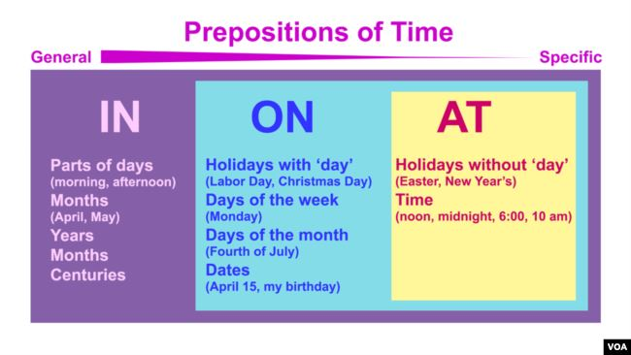

Everyday Grammar - Prepositions of time

**Prepositions and Place**

When English speakers refer to a place, we use in for the largest or most general places. You can say that “VOA is located in Washington, D.C.” And “for the best food, try the restaurants in Chinatown.”

For more specific places, like certain streets, we use the preposition on. You may know that President Obama lives on Pennsylvania Avenue in Washington, D.C.

Finally, we get to the most specific places. For exact addresses or **intersections,** we use the preposition at**.** If I invited you to visit us here at VOA, I would say, “Come to my office at 330 Independence Avenue.” To be exact, it’s at the corner of Independence and 3rd Street.”

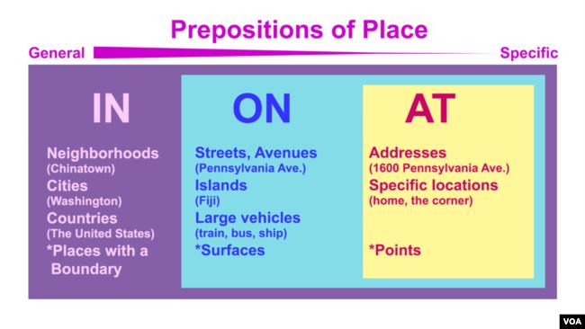

Everyday Grammar - Prepositions of Place

In English, though, there is always an ‘exception to the rule.’ When talking about transportation, things get a little hard to understand. We use on for public vehicles like buses or trains, but also for smaller ones like a bicycle. “I rode there on my bicycle.” However, you ride in a car.

Still, it helps to know that English prepositions do have some rules.

Following the “general to specific” rule should help you most of the time.

I’m Jill Robbins. And, I’m Ashley Thompson.

*Dr. Jill Robbins wrote this story for Learning English. Ashley Thompson was the editor.*